Thursday, March 4 | Los Angeles, CA to New Orleans, LA
 | Today, depart for your journey to New Orleans.  Flight itinerary: Overnight Flight (Red-Eye) - TBD  Overnight on plane
Friday, March 5 | New Orleans
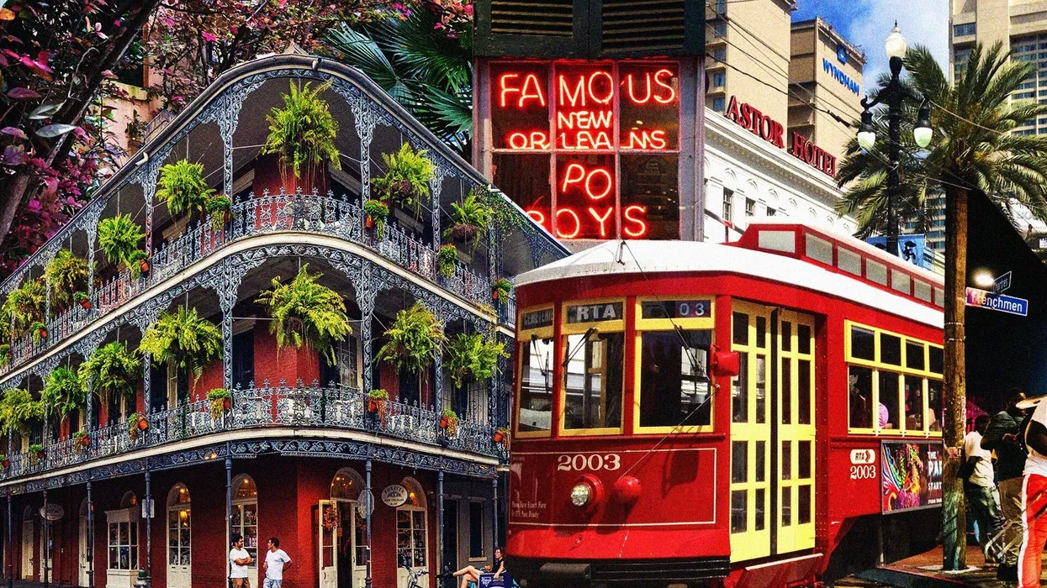  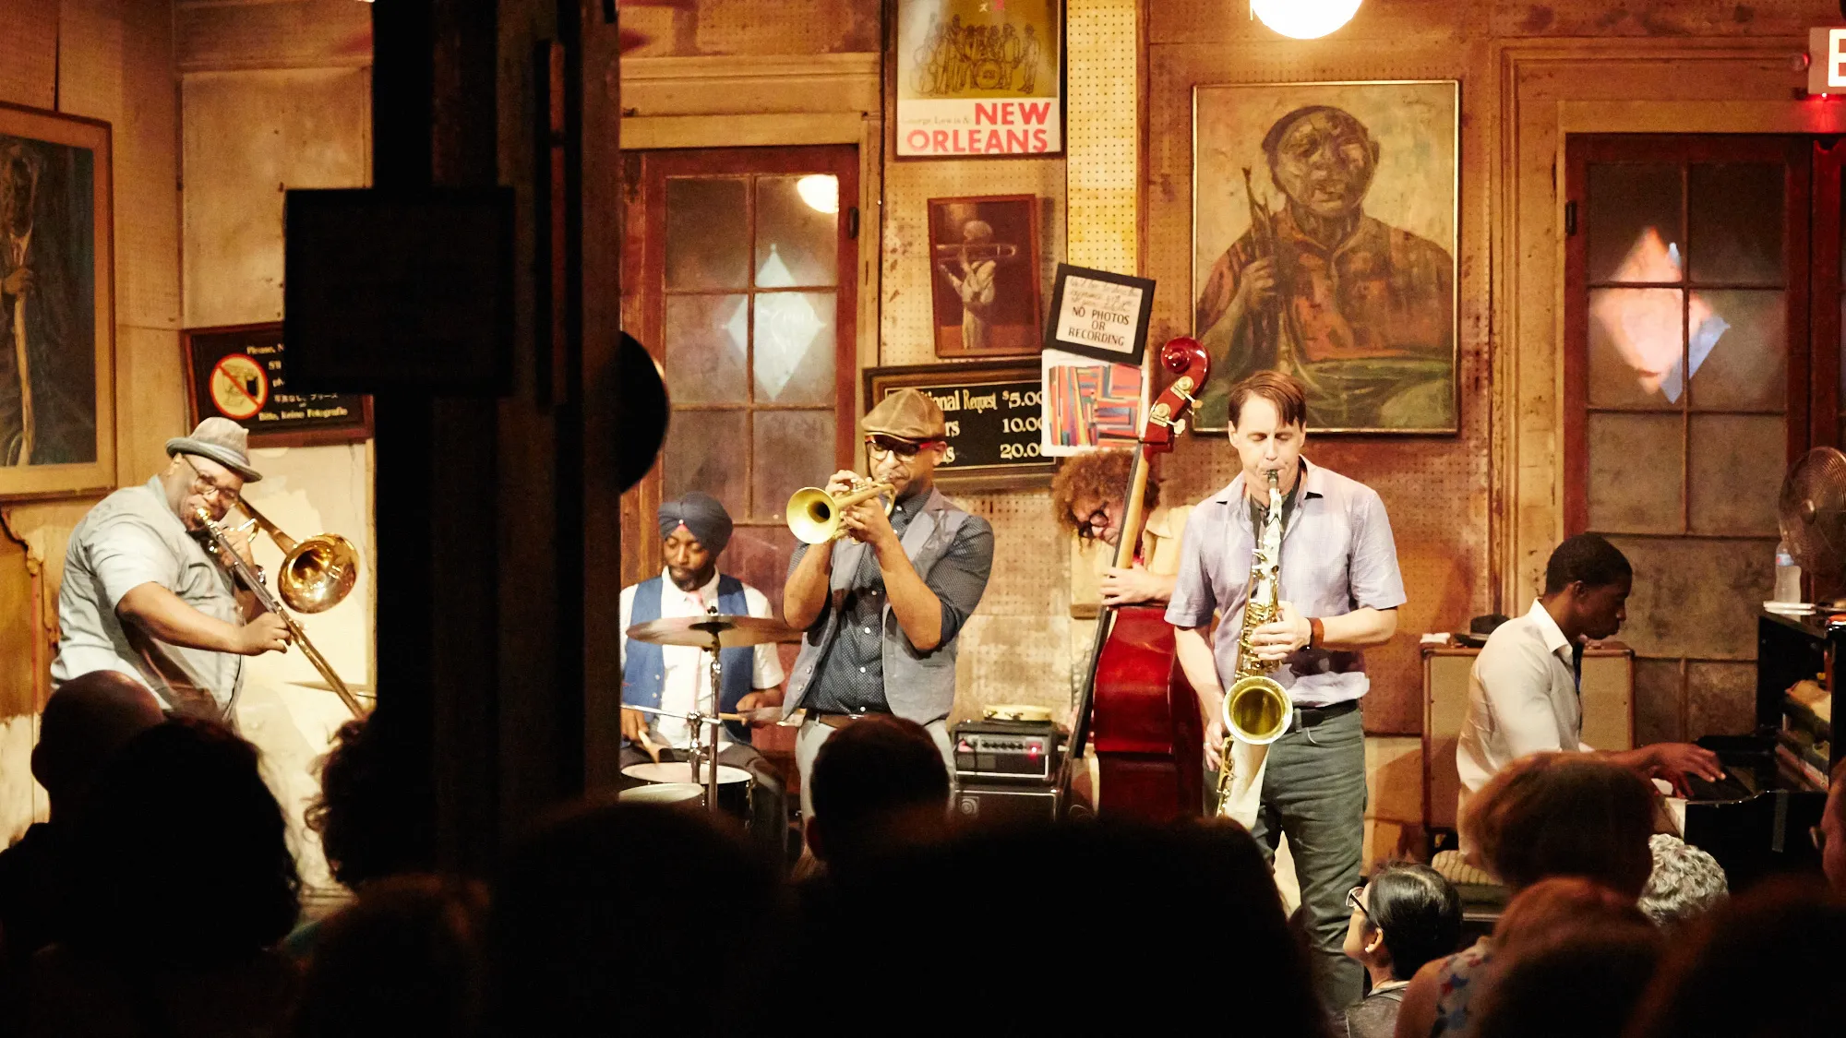  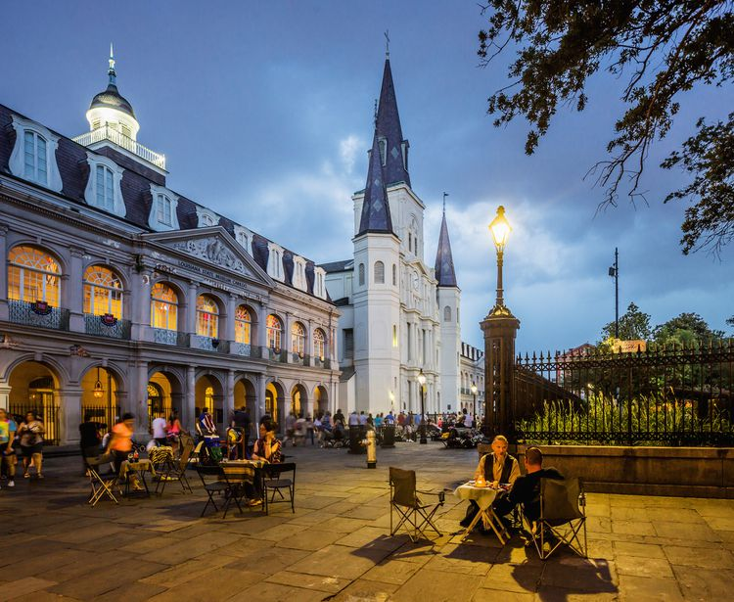 | Early morning arrival in New Orleans. Meet your Tour Manager who will be with you for the duration of your stay in New Orleans.  Breakfast provided upon arrival followed by a walk through the Historic French Quarter  - French Quarter, also known as Vieux Carré, is the oldest neighborhood in the city of New Orleans  Today, visit the historic Preservation Hall  - Since its founding in 1961, Preservation Hall has been dedicated to preserving New Orleans musical traditions, committed to the preservation of New Orleans Jazz and to caring for elder musicians.  - Participate in ‘Kids in the Hall’ experience – a one-hour experience, centered around the history of New Orleans music, students engage and listen to a Preservation Hall band perform, and have the opportunity for a Q&A session with members of the Preservation Hall collective.  Lunch ON YOUR OWN  This afternoon, further explore the French Quarter, in small groups, before going to your hotel for check-in  Dinner provided at a local restaurant  Overnight at Hotel
Saturday, March 6 | New Orleans
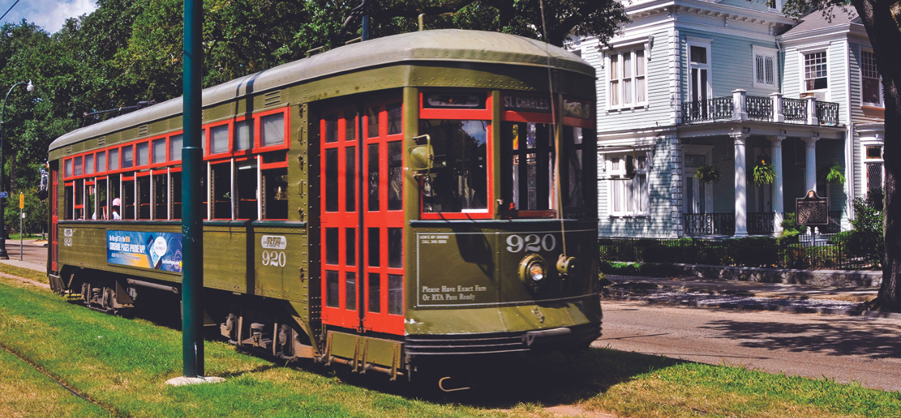  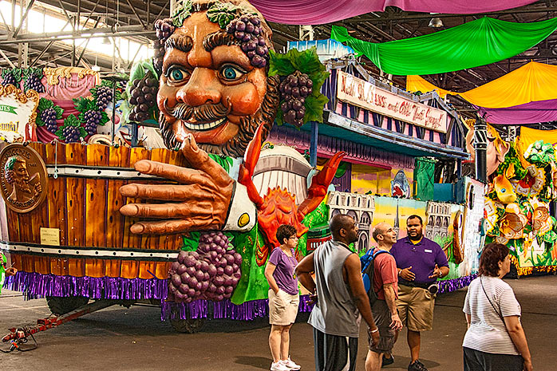  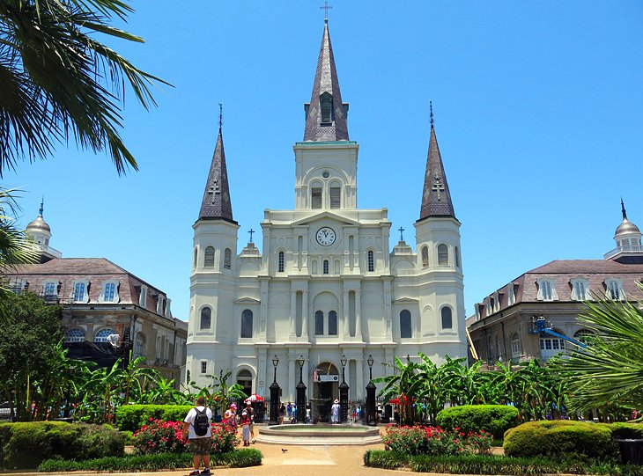  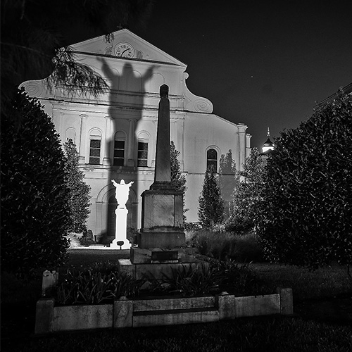 | Breakfast @ Hotel. This morning, enjoy a ride one the historic streetcars that runs on the St. Charles Line from the edge of the French Quarter to the Garden District. Upon arrival, visit and enjoy a choral clinic at one of the local Universities – Tulane University, Loyola University New Orleans, or similar  Lunch ON YOUR OWN  Enjoy another ride one the historic streetcars that runs back to the French Quarter  This afternoon, enjoy a visit to Mardi Gras World Museum  - The colors, the lights, the music, the joie de vivre. It’s all here in one magical place where you can peek behind the curtain and see Mardi Gras in the making. You haven’t truly experienced Carnival until you’ve explored Mardi Gras World.  Later this afternoon, visit Jackson Square and St. Louis Cathedral, and  - Possible performance opportunity today *Subject to availability  - The Saint Louis Cathedral is the oldest Cathedral in North America, founded as a Catholic Parish in 1720 along the Banks of the Mississippi River.  Also enjoy some free time to shop on the Riverwalk and to enjoy Riverfront Park  Dinner ON YOUR OWN  Tonight, experience a New Orleans Ghost Tour  - New Orleans may be the most haunted city in America. The word “haunted” has negative interpretations. Words like fear, torment, and howling ghouls come to mind. But in New Orleans, haunted is just another word for celebration. Spirits from all over the afterlife convene in The Big Easy because here, they co-exist with the living, and they love it. Why do you think all of our tombs are above ground? Enjoy an after-dark haunted cemetery bus tour, making several stops through the city’s most spiritually active graveyards and historic neighborhoods.  Overnight at Hotel
Sunday, March 7 | New Orleans
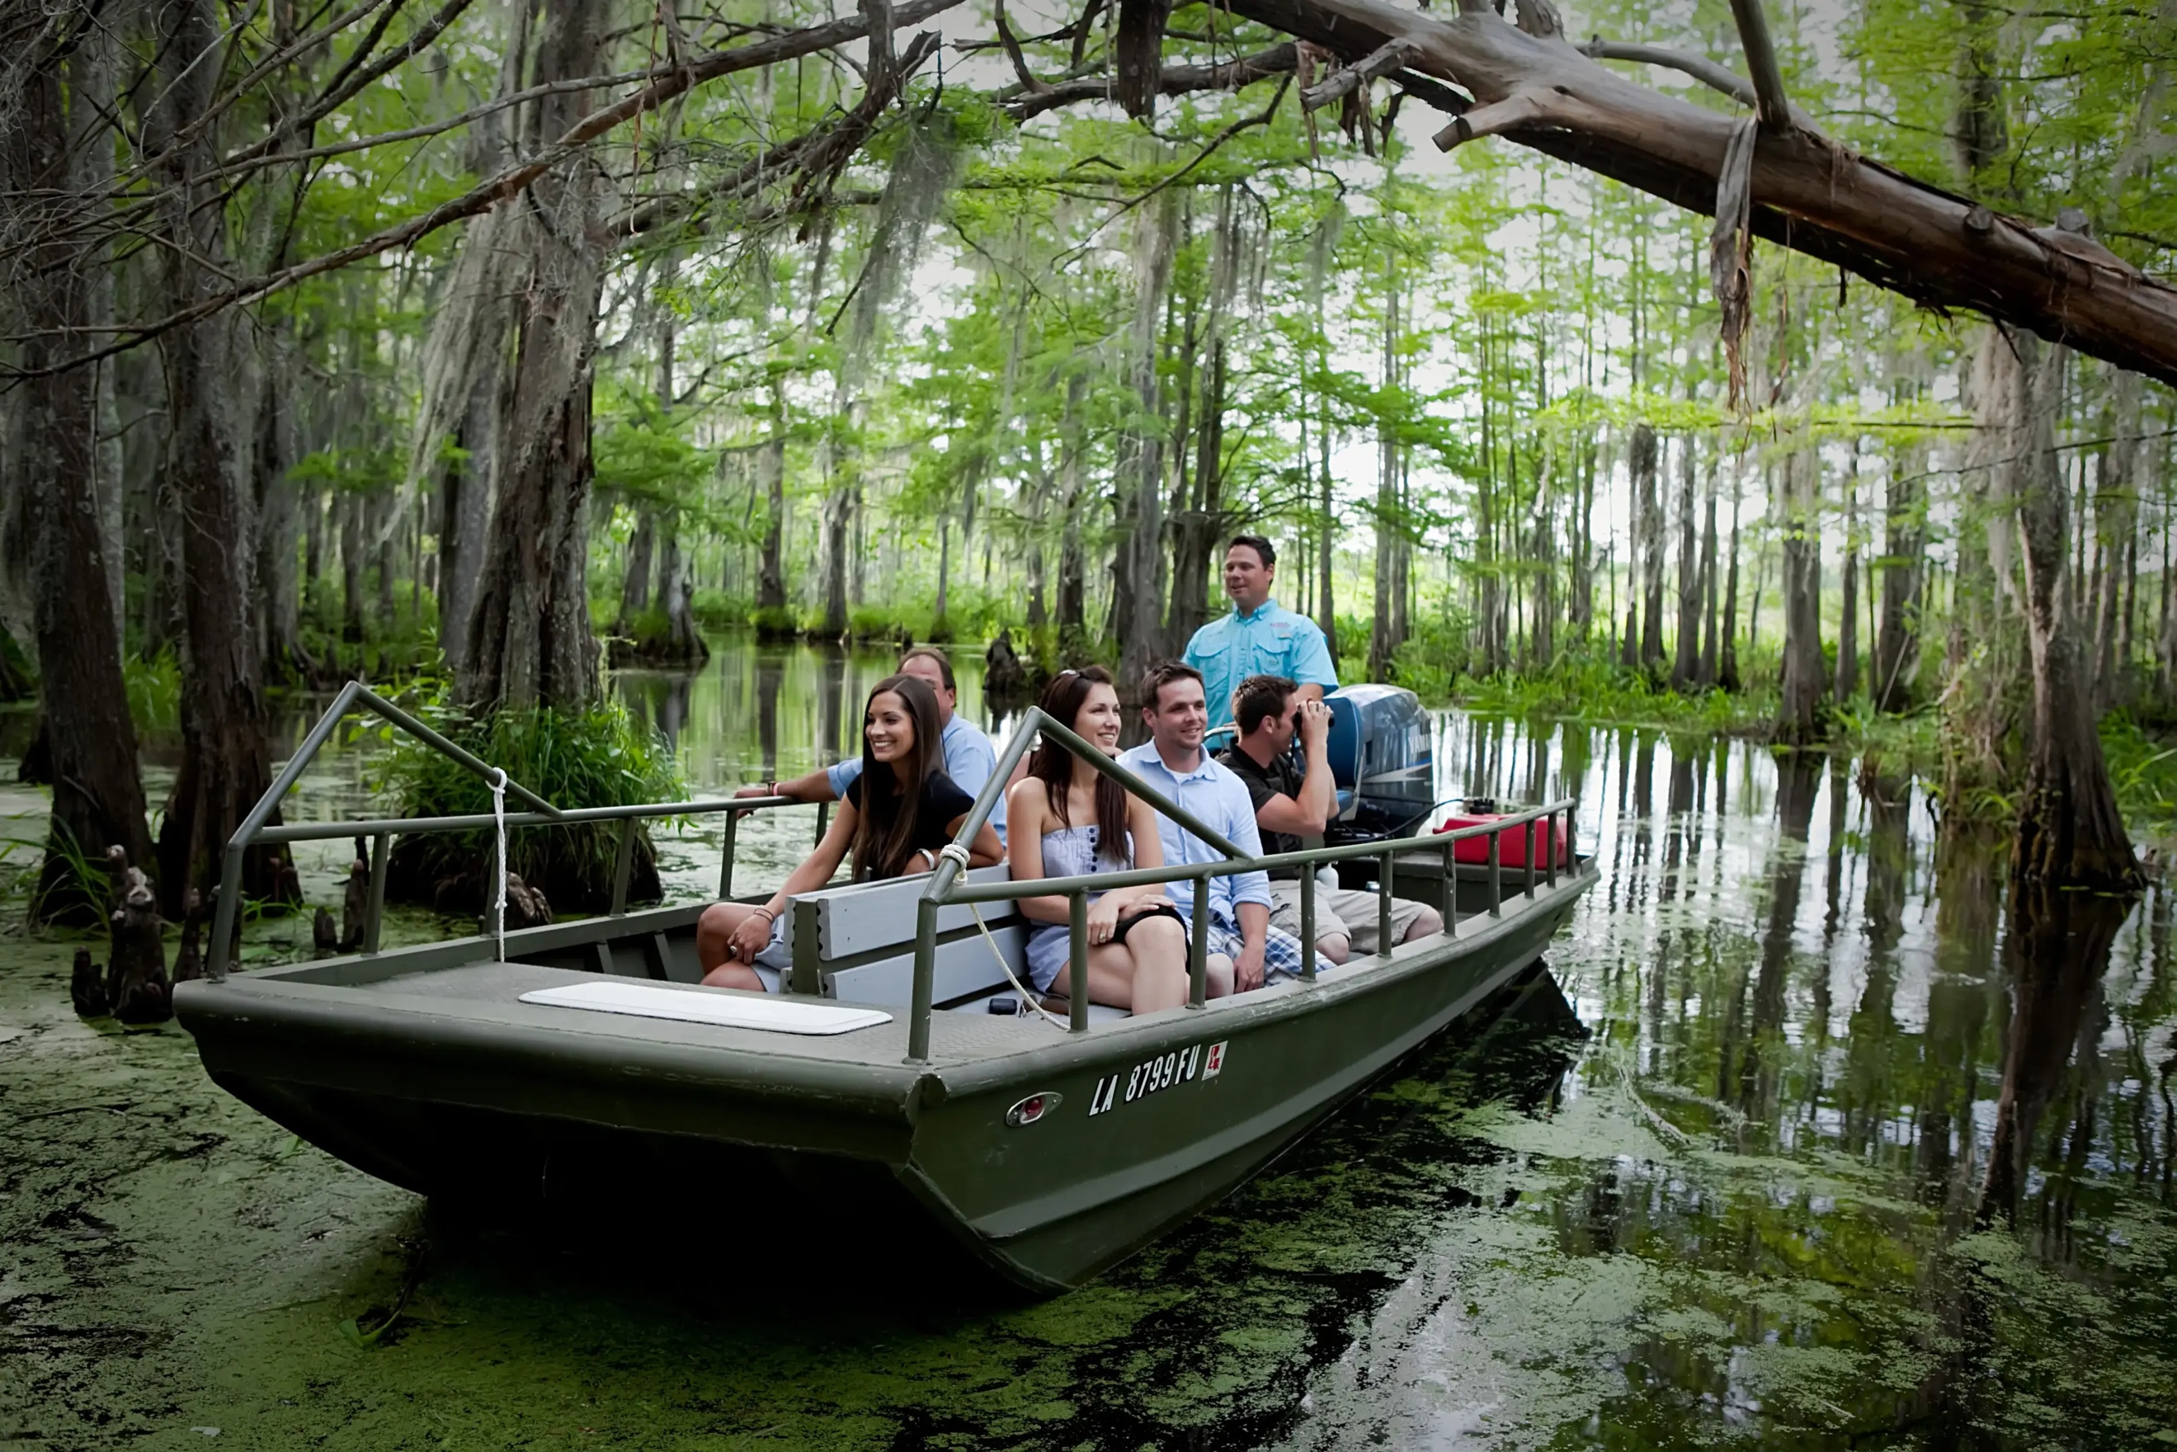  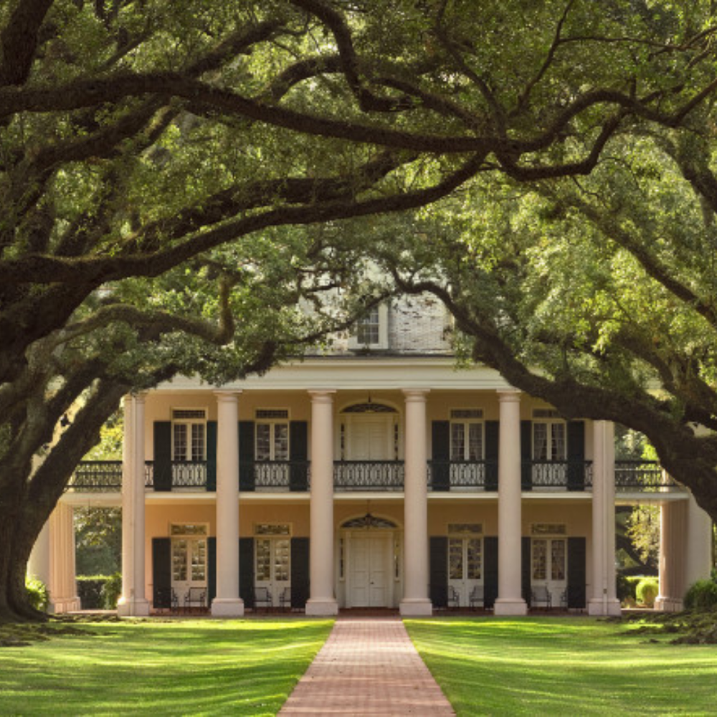  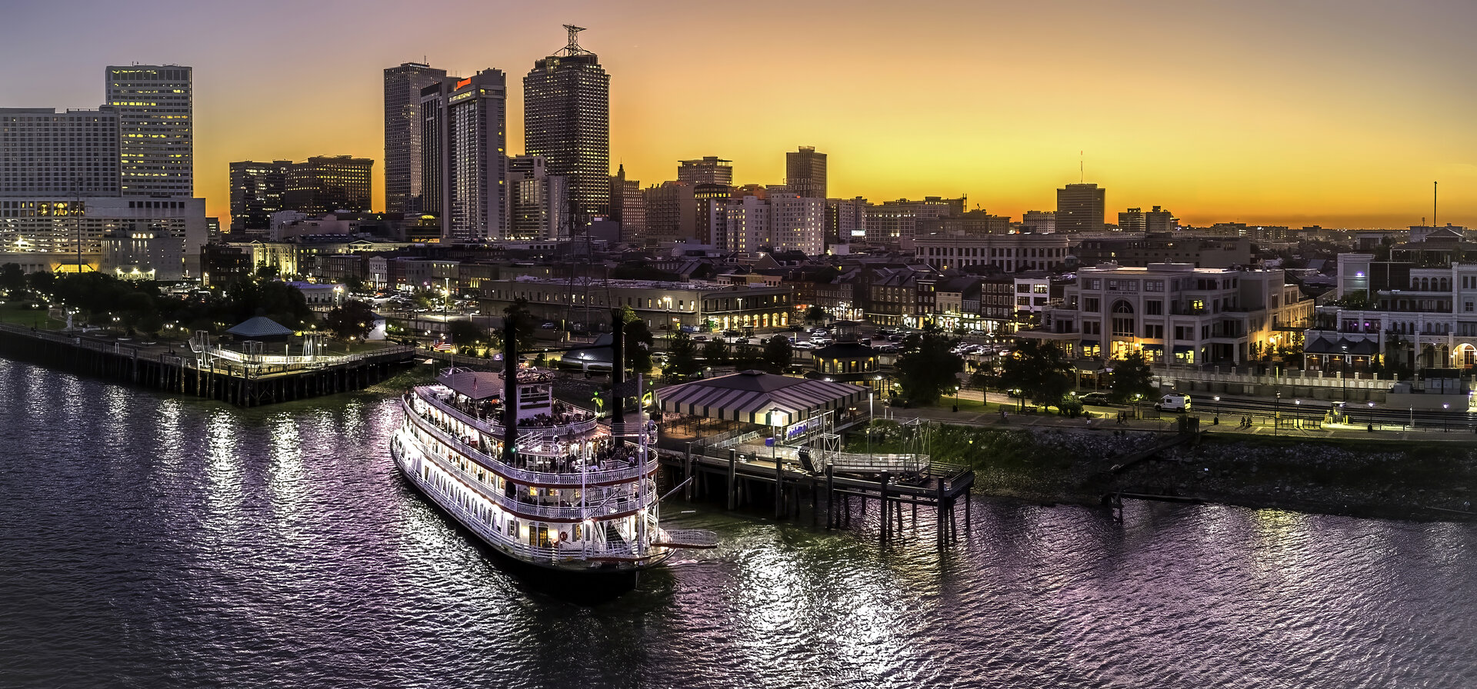 | Breakfast @ Hotel. This morning enjoy a Louisiana Swamp Tour with lunch provided  Following lunch, enjoy a Plantation Tour  - Step back in time to visit one of New Orleans most famous plantations: Oak Alley for its breath-taking tunnel of 28 live oak trees. Hear the fascinating stories behind this historic landmark. During the scenic drive out to the plantation, your certified tour guide will provide commentary on major landmarks and the changing Louisiana landscape, from downtown New Orleans, to the swamps and waterways, and through the vast crops and fields unique to this part of the country.  Tonight, experience the Mississippi River on the Steamboat Natchez for a New Orleans Dinner Cruise, a must for your trip to New Orleans!  - The sounds of a lively jazz band fill the air as you enjoy a lavish Creole buffet in elegantly appointed dining rooms.  Overnight at Hotel
Monday, March 8 | New Orleans to Los Angeles, CA
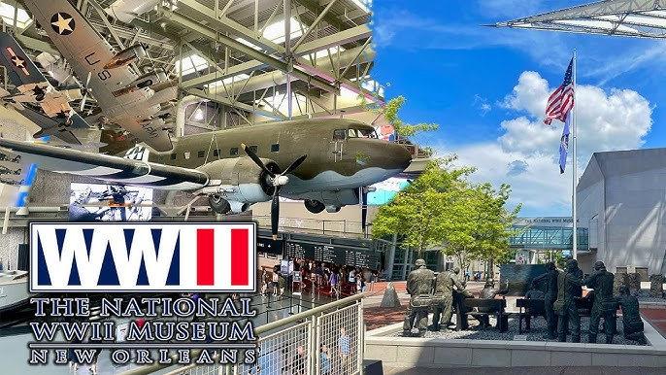  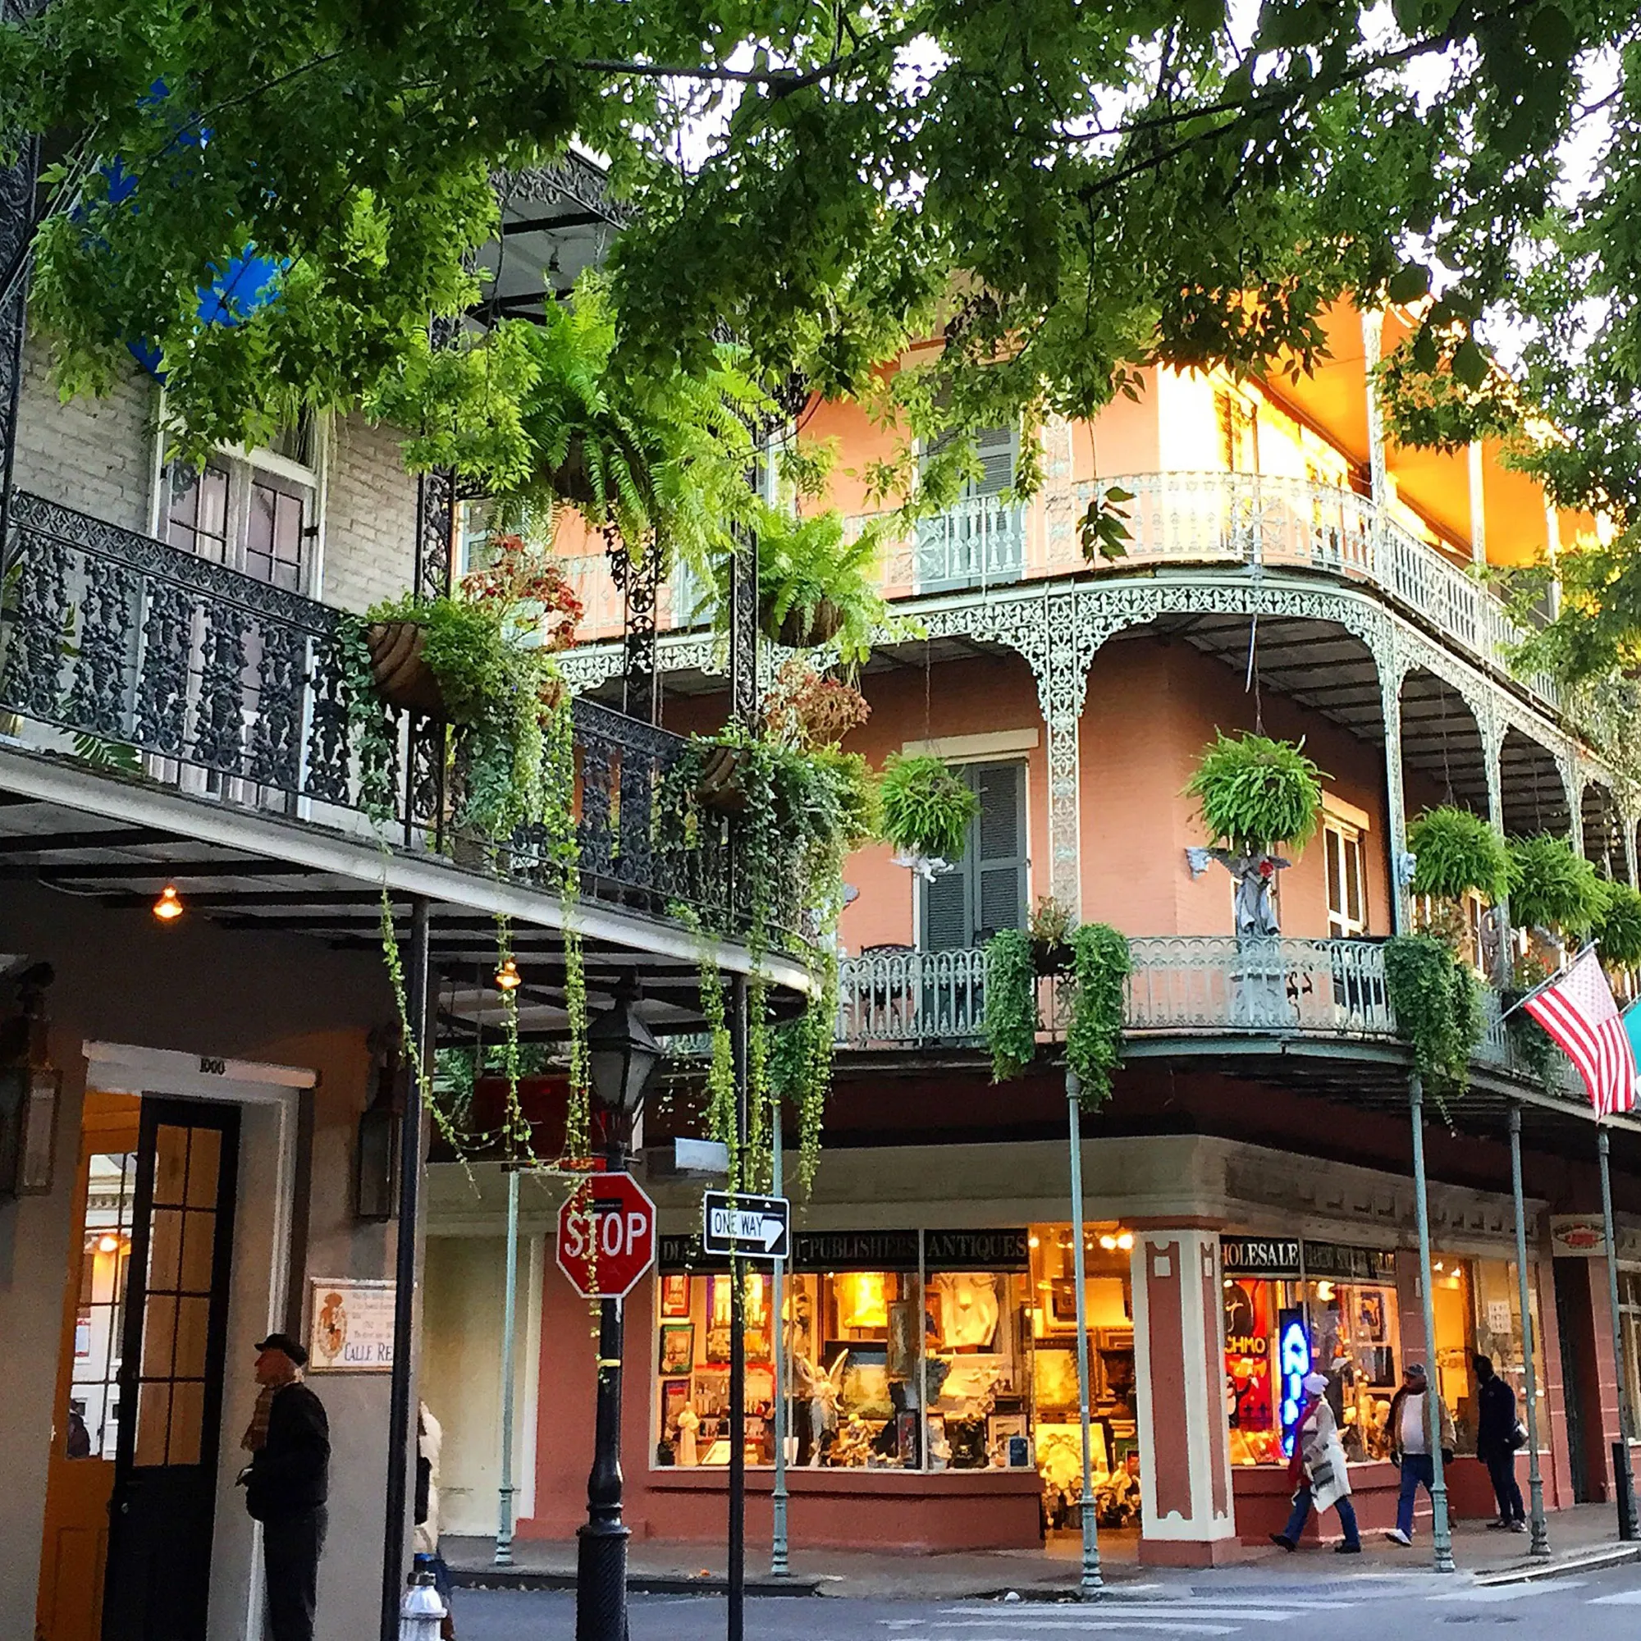 | Breakfast @ Hotel.  This morning, check-out and store luggage.  This morning, enjoy a visit to the National WWII Museum  - Features 4D films, immersive exhibits, and a submarine exhibit, making it ideal for history students.  - Possible performance opportunity today  Visit the French Market District  - Since 1791, the historic French Market has remained an enduring symbol of pride and progress for the people of New Orleans.  - We suggest you try one of the famous beignets for Café Du Monde  Lunch ON YOUR OWN  Additional free-time according to your departure schedule.  Late afternoon, board your coach and transfer to the airport for return trip home to Los Angeles.  Flight itinerary: TBD  WELCOME HOME!!

NOTE: CURRENT PROPOSAL IS A DRAFT AND SUBJECT TO ADJUST

September 3, 2026 Tour Cost & Inclusions
Prepared Especially for:
Aliso Niguel High School Choir – New Orleans Tour

Number Traveling: 40-50 paying participants

Costs Per Person:

LAND/AIR package $1,600.00 – quad/triple occupancy (students) and double occupancy (chaperones)
*Single supplement + $375

- Your tour costs are based upon total number of paying participants. You will receive one complementary director’s package (land/air) for the first 25 paying participants. (#26 is free)
- Receive additional complimentary tours (land only) for every 25 paying participants and are based upon double occupancy or higher (above the initial 25 paying participants)

Your Tour Experience Includes (Subject to availability)
- Three (3) nights accommodation in centrally located New Orleans Hotel; + one (1) overnight in flight
- Round-trip Airfare between Los Angeles and New Orleans
- One (1) Motor Coach – for New Orleans Airport transfers and transportation as needed within NOLA
  - Coach and Streetcar Transportation will be used
- Meals provided, per itinerary:
  - Four (4) Breakfasts
  - One (1) group Lunch
  - One (1) New Orleans Dinner Cruise + one (1) additional Group Dinner
- One (1) clinic opportunity at area University;
- Attend the ‘Kids in the Hall’ experience @ Preservation Hall
- Additional performance opportunities (*subject to availability):
  - St. Louis Cathedral and National WWII Museum
- Visit to Jackson Square Park, Historic French Quarter, St. Louis Cemetery No. 1, St. Louis Cathedral, and the Garden District
- Entrances/Excursions:
  - Mardi Gras World Museum
  - National WWII Museum
  - New Orleans Plantation Visit
  - New Orleans Ghost/Cemetery Tour
  - Louisiana Swamp Tour
- All taxes and gratuities for restaurants, hotels, and coach drivers
Plus
- A professional Sechrist Travel Tour Director on site to handle all tour arrangements with concern and care for the needs of your group
- A complete Itinerary handbook for your use
- $2M Liability Insurance Coverage, as recommended for Student and Your Travel Association (SYTA)

Tour Cost Does Not Include
- Medical & Trip cancellation insurance - *options provided during the registration process for an additional cost
- Tips for Tour Manager and Local City Guides
  - Recommended: Tour Manager ($3-$5 per person, per day)
- Meals not indicated in “Inclusions”
- Entrance fees for locations/sights you visit on your own
- Items of a personal nature (laundry, internet and phone charges, souvenirs, etc.) and any other items not mentioned as included.
- Anything not mentioned in “Your Tour Experience Includes" above
- Portage of luggage, optional excursions, independent meals, and any items not mentioned as included.
***Please note, until the number of participants is secured, these prices and activities are estimated. On your actual travel dates, activities might not be available or vendor/festival prices and inclusions may be different than estimated

Confirmation must be received in the form of a $200 registration deposit, per person, by September 18, 2026

